You are the Deep Cover Spy. You have no actions. You simulate the HMM. Each round, you secretly perform a state transition according to the transition probabilities, then offer a public observation based on the sensor probabilities. Roll a die to determine the start.
Transition:
Roll one die. Move to the appropriate next state based on the result
Sensor:
Roll one die.
1 – 2: Lie. Cover up the true option: Left, Center, Right. If 1, report the left-most option. If 2, report the right-most option.
3 – 6: Tell the truth. Left, Center, or Right.

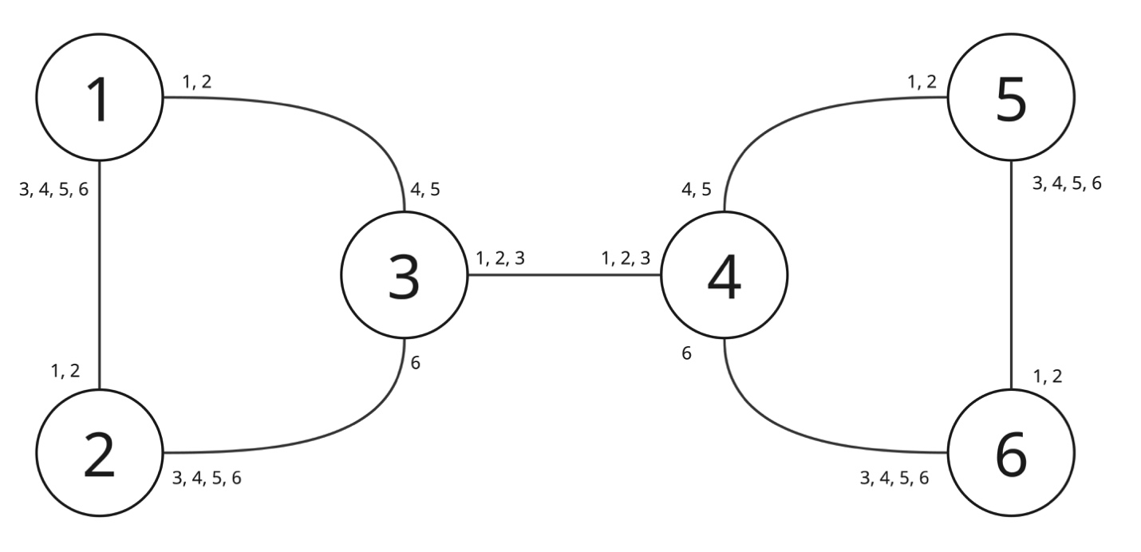
ROUND 1 – Initial State:
State: ____ ____ ____ ____ ____ ____
Observation: ____ ____ ____ ____ ____ ____
ROUND 2 – Initial State:
State: ____ ____ ____ ____ ____ ____
Observation: ____ ____ ____ ____ ____ ____
ROUND 3 – Initial State:
State: ____ ____ ____ ____ ____ ____
Observation: ____ ____ ____ ____ ____ ____

You are the Deep Cover Spy. You have no actions. You simulate the HMM. Each round, you secretly perform a state transition according to the transition probabilities, then offer a public observation based on the sensor probabilities. Roll a die to determine the start.
Transition:
Roll one die. Move to the appropriate next state based on the result
Sensor:
Roll one die.
1 – 2: Lie. Cover up the true option: North, Center, South. If 1, report the left-most option. If 2, report the right-most option.
3 – 6: Tell the truth. North, Center, or South.

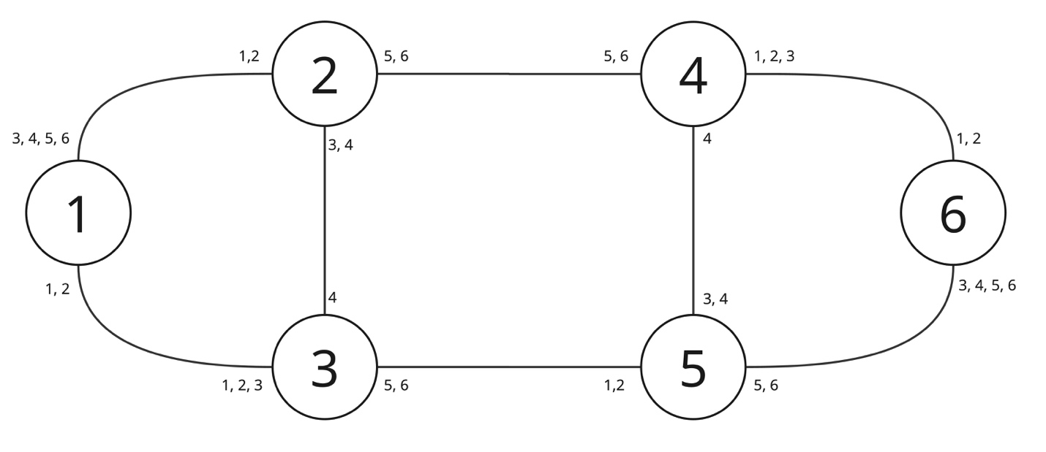
ROUND 1 – Initial State:
State: ____ ____ ____ ____ ____ ____
Observation: ____ ____ ____ ____ ____ ____
ROUND 2 – Initial State:
State: ____ ____ ____ ____ ____ ____
Observation: ____ ____ ____ ____ ____ ____
ROUND 3 – Initial State:
State: ____ ____ ____ ____ ____ ____
Observation: ____ ____ ____ ____ ____ ____

You are the Hunter Spy. Your goal is to capture the Deep Cover Spy. Your actions are: Move to an adjacent state, Stay in your current state, or Capture in your current state. Roll a die to determine your start state.
Move:
Move deterministically to an adjacent state.
Stay:
Stay in your current state.
Capture:
If the Deep Cover Spy is in the same state as you, you capture them and end the game. If not, you blow your cover, and the Deep Cover Spy will not transition into this state next turn.
ROUND 1
Observation: ____ ____ ____ ____ ____ ____
Prediction: ____ ____ ____ ____ ____ ____
Action: ____ ____ ____ ____ ____ ____
ROUND 2
Observation: ____ ____ ____ ____ ____ ____
Prediction: ____ ____ ____ ____ ____ ____
Action: ____ ____ ____ ____ ____ ____
ROUND 3
Observation: ____ ____ ____ ____ ____ ____
Prediction: ____ ____ ____ ____ ____ ____
Action: ____ ____ ____ ____ ____ ____
You are the Hunter Spy. Your goal is to capture the Deep Cover Spy. Your actions are: Move to an adjacent state, Stay in your current state, or Capture in your current state. Roll a die to determine your start state.
Move:
Move deterministically to an adjacent state.
Stay:
Stay in your current state.
Capture:
If the Deep Cover Spy is in the same state as you, you capture them and end the game. If not, you blow your cover, and the Deep Cover Spy will not transition into this state next turn.
ROUND 1
Observation: ____ ____ ____ ____ ____ ____
Prediction: ____ ____ ____ ____ ____ ____
Action: ____ ____ ____ ____ ____ ____
ROUND 2
Observation: ____ ____ ____ ____ ____ ____
Prediction: ____ ____ ____ ____ ____ ____
Action: ____ ____ ____ ____ ____ ____
ROUND 3
Observation: ____ ____ ____ ____ ____ ____
Prediction: ____ ____ ____ ____ ____ ____
Action: ____ ____ ____ ____ ____ ____

